Punctuality |  | Attendance |  | Mercenfeld Primary School  Uniform, Outstanding Payments, Behaviour, Attendance and Punctuality  Guidance for Parents  For full information please visit our website for these and other policies
School gates open at 8:40am each day. To avoid congestion please avoid arriving prior to this. Registration will take place at 8.55am and close at 9.00am.  If your child arrives after 8.55am they will be marked as ‘late’. Please ensure that your child arrives on time as arriving late can cause disruption to the whole class and impacts on children’s learning.  If a child is late on a regular basis our Headteacher will write to you asking you to make sure your child arrives on time and if this continues you will be invited in to discuss the problems and the impact that this has on children’s learning.  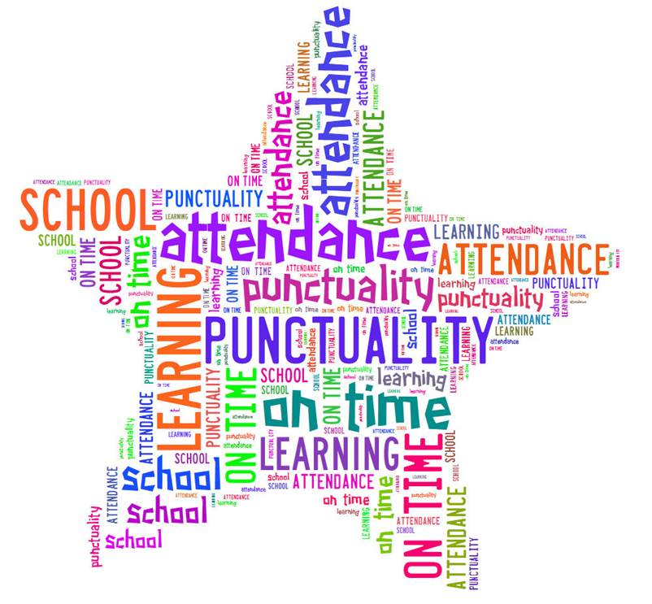 |  | Attendance is closely monitored and those children who achieve 100% attendance over the school year receive a certificate during our end of year assembly.  Poor attendance can seriously affect a child’s  - Attainment & Progress  - Relationships with peers  - Confidence & Self-esteem  Good attendance is defined as above 95%. When it falls below this a letter will be sent out to inform you of our concerns. If attendance concerns continue, you will be invited into school to discuss how we can support you with improving this and on occasions a referral may be made to our Educational Welfare Officer.  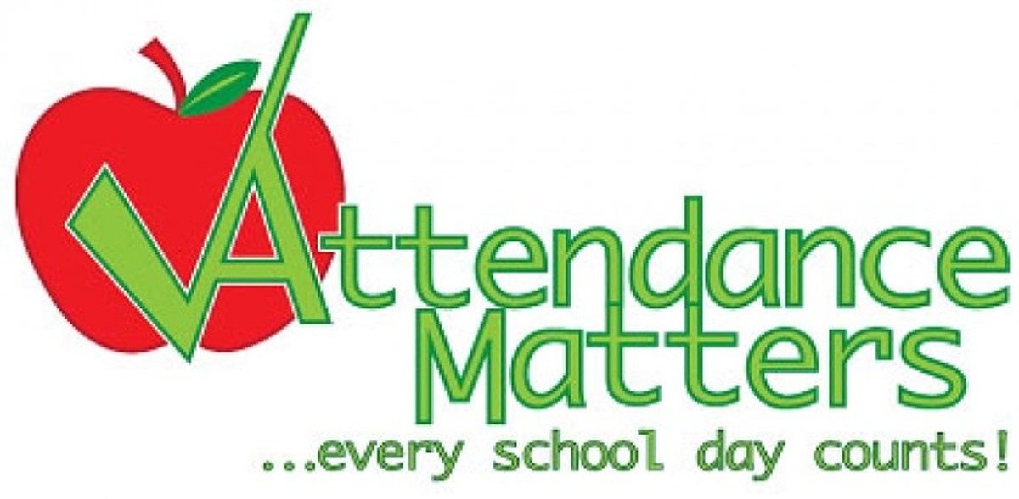  % Absent Definition  100% 0 days Excellent  97% 6 days Very Good  95% 10 days Good  90% 19 days Unsatisfactory  85% 29 days Cause for concern  80% 1 day every week Serious cause for concern
Uniform |  | Outstanding Payments |  | Behaviour
Wearing a school uniform helps pupils:  - to foster respect and pride in appearance  - to help establish a positive attitude to school  Mercenfeld Uniform  Sweatshirt – Red with or without the school logo.  Cardigan - Red with or without the school logo.  Polo shirt - White or red with or without the school logo.  Trousers - Black or grey, NOT jeans  Skirts - Black or grey.  Pinafore Dresses - Black or grey.  Summer Dress - Red and white checked dress  Footwear - Practical sensible dark shoes. Trainers, heels, open toes and flip flops must be avoided  Coats & Jackets – An appropriate coat or jacket depending on the weather  Mercenfeld PE & Games Kit  Shorts - Plain dark shorts.  T-shirt - White with or without the school logo.  Pumps - Elasticated black pumps.  Trainers - An inexpensive pair of trainers for outdoor P.E.  Jogging Bottoms & Sweatshirt - Inexpensive jogging bottoms and/or a sweatshirt may be worn for outdoor P.E. (This is not required for EYFS pupils)  PE Kit must be in school each day  PE Kit with the Mercenfeld Logo is available  Earrings must be removed or covered with tape  PLEASE NAME ALL ITEMS OF CLOTHING |  | Outstanding payments or non-payment of dinners, milk, trips, after-school clubs and swimming have a negative impact on the school’s budget. You can help us avoid this by keeping up-to-date with payments.  If payments are outstanding the following course of action may be taken:  - Text or telephone reminder  - Letter from Headteacher  - Hot meals being cancelled until payment is received and future payments to be made in advance  - Possibility of legal action  Pupil Premium  Free School Meals  If you are in receipt of tax credits or other benefits you may well be entitled to Pupil Premium funding. Please apply for this even if your child/children are eligible for universal Free School Meals (EYFS & KS1) as it means the school will receive funding which is used to support teaching/learning, subsidise extra-curricular activities and provide resources to support home learning. |  | We aim to create a supportive, fair, flexible, caring environment where all children;  - Have self-respect and a high self esteem  - Respect others within our community  - Have the right to be treated equally  - Feel safe  - Have a voice and can express their opinion  We expect behaviour in our classrooms and around the school to be:  - Respectful  - Positive  - Cooperative  - Considerate  - Responsible  We operate a green, amber, yellow, red card system to help the children understand there are consequences to their actions. This is a system where the child is encouraged to improve and maintain their behaviour and self-esteem. Good behavior is rewarded through praise, stickers, star assemblies, half-termly celebration activities and end of term treats.  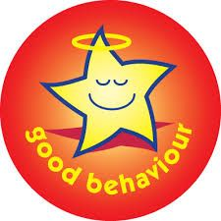  Depending on the level and frequency of inappropriate behavior being displayed, parents may be informed and occasionally invited into school to discuss the situation.

